NORTH EAST LINCOLNSHIRE CLINICAL COMMISSIONING GROUP
TERMS OF REFERENCE

COMMUNITY FORUM

1. PURPOSE

The Community Forum is part of the CCG’s governance arrangements (Appendix 1) that exist to provide assurance to the CCG Governing Body that patients, service users, carers and the public are effectively engaged and involved in decisions made about health and social care services in North East Lincolnshire in keeping with the North East Lincolnshire Commitment and joint community engagement strategy – “Talking Listening and Working Together”

2. ACCOUNTABILITY

The Chair of the Community Forum reports to the CCG Governing Body

The Community Forum is a permanent committee of the CCG and remuneration is set by the CCG’s Remuneration Committee.

3. REPORTING

Community Forum minutes and the “So What?” Evaluation Report are received by CCG Governing Body

4. CONSTITUTION

The Community Forum is an integral part of the CCG governance structure. Community members are very much a part of the CCG and are expected to conduct themselves with integrity and in keeping with the principles and values of the NHS constitution.

5. COMMITTEE CHAIR AND DEPUTY CHAIR

The forum will appoint a Chair and Vice-Chair as part of an election process every three years. (appendix 2)

6. MEMBERSHIP

The Community Forum comprises of Community Leads who are been formally appointed to the follow areas of work with the CCG:

- Women and Children’s
- Planned Care and Cancer
- Mental Health and Disabilities
- Community Care
- Long Term Care and Support
- Patient Experience
- Long Term Conditions
- Primary Care

- Equality & Diversity
- Communications and Engagement
- Care Contracting
- Information Governance and Audit

- Other roles as determined by the CCG

These posts are filled via expressions of interest from the Accord membership scheme using the agreed Recruitment & Selection process. (Appendix 2 provides the criteria for eligibility).

Attendees of the Community Forum are as follows:

- CCG Executive Leadership representative
- CCG Engagement Lead
- Business Support Administrator (minute taker)

The Community Forum may request the attendance of any member of staff or senior/clinical lead from the CCG or outside organisations as and when appropriate.

The Chair of the Accord Steering Group has an invitation to attend Community Forum meetings where appropriate

7. QUORACY

The Community Forum will be quorate if any six members are present.

Where a quorum cannot be convened from the membership of the meeting, owing to the arrangements for managing conflicts of interest or potential conflicts of interest, the Chair of the meeting shall consult with the Conflicts of Interest Guardian or Chief Finance Officer on the action to be taken

8. ROLES AND RESPONSIBILITIES

The roles and responsibilities of the Community Forum are as follows:

- To oversee, challenge and hold the CCG to account around involving local people in their decision making.

- To provide a conduit between the CCG and the Community Forum through the attendance of the Chair of the Community Forum at the Governing Body and Council of Members.

- To ensure that, through the various Service Areas, Working Groups and Committees, engagement with the wider community, including accord members, is undertaken to gather information and views and inform decisions

- To offer practical support to new projects where community engagement is required

- To highlight areas of concern raised by the wider community and potential need for change, where appropriate

- To listen to, discuss and agree new proposals/changes that are required, challenging decisions, where appropriate

- To ensure that any proposals and/or decisions regarding services, service change, etc. have had relevant community involvement and adhere to the principles of the North East Lincolnshire Commitment

- To support the CCG’s arrangements to meet the Public Sector Equality Duty in considering the needs of groups who share a protected characteristic when planning and buying services

9. DECLARATIONS OF INTERESTS, CONFLICTS AND POTENTIAL CONFLICTS

All committee/subcommittee members must adhere to the CCG’s Constitution and Standards of Business Conduct / Conflicts of Interest policies, together with NHS England statutory guidance on managing conflicts of interest.

Where a member of the committee/subcommittee/group believes that he /she has a conflict of interest in relation to one or more agenda items, they must declare this at the beginning of the meeting wherever possible, and always in advance of the agenda item being discussed. It will be responsibility of the Chair to decide how to manage the conflict and the appropriate course of action.

To further strengthen scrutiny and transparency of CCG’s decision-making processes the CCG has an appointed Conflict of Interest Guardian. This role is undertaken by the CCG’s Integrated Governance and Audit Chair.

Any interests which are declared at a meeting must be included on the CCG’s Declaration of Interest Register. Where this is not already the case, the individual with the conflict must ensure that the item is added to their declaration as soon as is practicable following the meeting.

10. FREEDOM OF INFORMATION ACT 2000

The minutes and papers of this forum are, in the main, classed as public documents, except where matters, usually due to draft work in progress, issues of confidentiality or commercial sensitivity, are specifically deemed to be unsuitable for publication.

11. MEETING PAPERS

The Chair and the Vice Chair of the Forum, the CCG Executive Leadership representative and the Engagement Lead will draw up the agenda for each meeting.

The agenda and papers will be distributed five working days in advance of the meeting.

12. FREQUENCY AND NOTICE OF MEETINGS

The Community Forum will meet monthly

Meetings of the Community Forum will be planned for the calendar year ahead.

13. ADMINISTRATIVE SUPPORT

Administrative support will be provided to the Community Forum by the Business Support Team.

14. REVIEW OF TERMS OF REFERENCE

The Community Forum will undertake a review annually of its efficacy as a committee and how well these Terms of Reference have been met.

Reviewed and agreed by the Community Forum on 2 December 2020

Approved by Governing Body 11 March 2021

Appendix 1
CCG Governance Structure
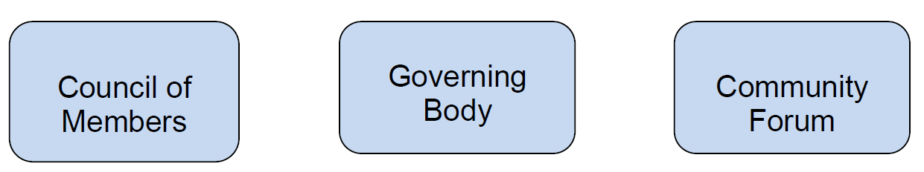

Appendix 2

Community Forum: eligibility criteria

North East Lincolnshire Clinical Commissioning Group’s (CCG) purpose is to commission services on behalf of the community relating to the health and social care needs of people in the area.

As part of their establishment CCGs were required to “make arrangements for the public to be engaged in governance arrangements by ensuring that the CCG Governing Body includes at least two lay people”.

North East Lincolnshire CCG has strengthened this commitment through the development of the Community Forum. Community members, drawn from the CCG’s Accord membership scheme, contribute to the CCG’s governance arrangements through formal appointments to a specific Community Lead role. These appointments are made through an agreed Recruitment & Selection Process.

The purpose of appointing Community Leads into these positions is to create a framework whereby there is assurance that the public have a direct say in what services are commissioned and drive the commissioning strategy of the CCG.

- Role of the Community Forum

The role of the Community Forum is to oversee, challenge and hold the CCG to account around involving local people in their decision making.

The Forum:

- provides a conduit for information for CCG and Community Members
- listens, discuses and agrees new proposals/changes that are required
- challenges decisions, where appropriate
- offers practical support to new projects where community engagement is required
- highlights areas of concern raised by the wider community and potential need for change, where appropriate
- it is not a forum to raise personal issues or complaints

- Community Lead Roles

People formally appointed to Community Lead roles in the CCG are therefore members of the Community Forum. These roles are determined by the CCG and are set out in the Community Forum Terms of Reference.

- Appointment of Community Leads

  - Formal appointments will follow the agreed Recruitment & Selection process.

  - Applicants must be over 16 years old and a member of Accord

  - Exclusions of eligibility are set in accordance with Appendix 3

- Election of the Chair / Vice Chair of the Community Forum

Expressions of interest will be sought from the Forum members for the roles of Chair and Vice-Chair and where there is more than one candidate a ballot of the Forum members will be carried out

In the event of either role not being filled the CCG will arbitrate to decide who takes the role(s)

The forum will appoint a Chair and Vice-Chair from their number every three years.

- Terms of Office

  - A term of office to an appointed role is three years

  - Incumbent members may serve for a second or third successive 3-year term of office subject to a dialogue between the CCG and the individual to confirm that both are content for the appointment to continue

  - There will be a regular process of individual reviews throughout the term of office with the escalation of any concerns or issues via the Forum chair

  - Where a vacancy occurs before completion of the three-year term this will be filled through the Recruitment and Selection process

  - A member may not hold more than one Community Lead position with a Service Team at any one time, however a member may serve on additional committees or working group at any one time

  - A member may not serve in an appointed role for more than two consecutive terms of office, however, in the event where no other suitable applications are received from candidates who meet the minimum criteria this may be extended to one further 3-year term

  - Good attendance at Forum meetings is essential in order for the community lead to carry out their role. Where a member is absent from more than two consecutive Forum meetings or is absent from 6 or more meetings over a 12-month period without reasonable explanation (as determined by the Chair), then the Chair will make contact to discuss the reasons for absence and commitment to the role; and this may result in termination of appointment

  - Where a member is unable to fully carry out their role due to ill health or personal matters, they may be granted an extended leave of absence in agreement with the Chair

- Notice

  - Where a Community Lead steps down from their role before completion of their term of office they are required, wherever possible, to give 3 months’ notice. This will enable a replacement to be appointed and for a period of handover between the two community leads to enable continuity of the role and work being undertaken.

  - If at any point the organisation deems that a Community Leads is:

- not effectively carrying out their role and cannot be supported to remedy that fact, or
- That they are in breach of the Forum’s Code of Conduct then they will be removed from that role with immediate effect.

  - Exit interviews will be held to gain feedback on the Community Lead’s experiences. This will support the effectiveness of both current and future Community Lead Roles.

- Definitions

Executives

To be appointed by the Clinical Commissioning Group.

Community Leads

Members of Accord formally appointed to named positions within the Community Forum

Service Areas

Clinical/community/managerial approach to health and social care commissioning

Clinical Commissioning Group

NHS North East Lincolnshire Clinical Commissioning Group, Municipal Offices, Town Hall Square, Grimsby, North East Lincolnshire, DN31 1HU

Appendix 3
Exclusions of eligibility

A person may not become or continue as a Community Representative if:

- he/she has within the preceding two years been dismissed, otherwise than by reason of redundancy or ill health, from any paid employment with a Health or Social Care Service Body

- he/she is a person whose tenure of office as the chairman or as a member or director of a Health or Social Care Service Body has been terminated on the grounds that his appointment is not in the interest of the health or care service

- he/she is a Director of the CCG, executive director, non-executive director, chairman, chief executive officer of another NHS Trust, except where he/she is a Governor by virtue of being the Appointed Governor of that NHS body

- he/she is a member of a Healthwatch Board

- he/she has had his/her name removed from a list maintained under regulations pursuant to the 2006 Act, or the equivalent lists maintained by Local Health Boards in Wales under the National Health Service (Wales) Act 2006, and he/she has not subsequently had his/her name included in such a list

- he/she is the subject of a Sex Offenders Order and /or his/her name is included in the Sex Offenders Register

- he/she has failed to repay (without good cause) any amount of monies properly owed to the CCG

- he/she has in the five years preceding his/her proposed election or appointment been confirmed as an ‘intractable complainant’ in accordance with the relevant CCG policy for handling complaints

- he/she is incapable, by reason of mental disorder, illness or injury, of managing and administering their property and affairs

- he/she is a member of the local authorities’ Overview and Scrutiny Committees covering health matters

- he/she is the spouse, partner, parent or child of a member of the Board of Directors of the CCG

- he/she has acted in a manner deemed contrary to the interests of the CCG

- he/she is a person who within the preceding 5 years has been convicted in the British Islands of any offence if a sentence of imprisonment (whether suspended or not) for a period of not less than 3 months (without the option of a fine) was imposed on him/her.
Appendix 4
Recruitment and Selection process

The Engagement Team will provide administrative support to the recruitment and selection process

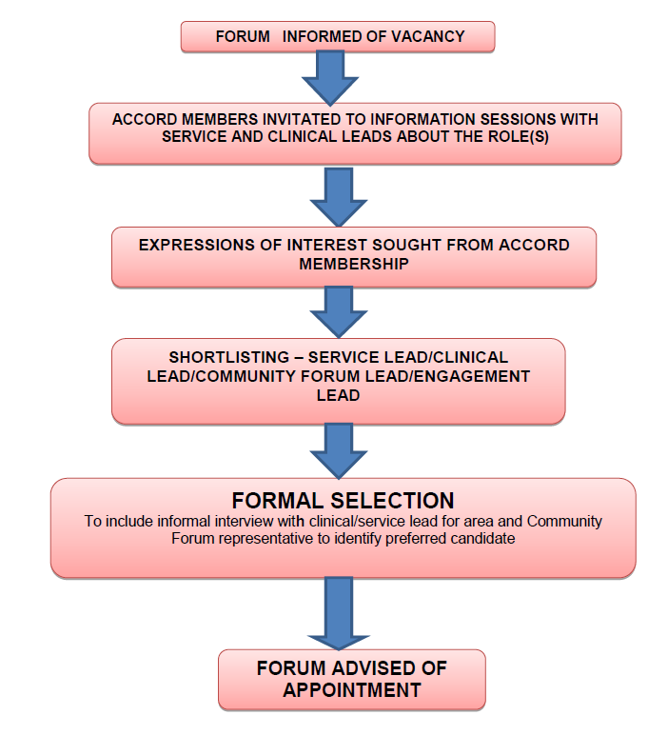

Appendix 5

Community Lead Role Description

The community lead works alongside the managerial and clinical leads for their appointed area of responsibility.

You will provide a community perspective as help to develop and shape plans, policies and proposals. Your role is to ensure local people are listened to and involved in commissioning plans; and their views are taken into account.

With your managerial and clinical lead(s) you will develop a work plan to:

- Champion engagement and communications

- Provide advice and practical support to ensure appropriate community involvement in the development of plans and proposals
- Develop links and networks with relevant local voluntary and community groups to gain views and feedback
- Put forward views and comments, based on knowledge gathered from Accord members, the Community Forum, patients, service users, carers, the general public and local voluntary and community groups to the CCG where appropriate
- Ensure that engagement with the local community is meaningful and people can see the difference their involvement has made
- Challenge – where appropriate - decisions or activity that do not appear to have had public/user/carer involvement
- Help promote the outcomes of the CCG’s approach of clinical, managerial and community leadership within your appointed area helping to communicate improvements and successes.

- Participate in planning and monitoring

- Contribute to the development of plans, policies and proposals from a community perspective.
- Help to shape and redesign services including service specifications and patient pathways
- Support procurement activity including participation in tender evaluations where appropriate
- Work closely with the managerial and clinical lead(s) to ensure that any proposals and/or decisions regarding service change(s) have had meaningful patient and public involvement and provide challenge where appropriate to ensure this happens
- Develop an annual work plan/agenda forward plan for your appointed area with the managerial and clinical lead(s) and help monitor progress.
- Present information at Community Forum meetings on developments in your service area

- Work collaboratively to ensure the work of the CCG results in:

- Improvements both in quality and the user/carer experience of the services
- All people in North East Lincolnshire have opportunities to live a healthy life no matter where they live or who they are, and
- Value for money

General:

- Undertake statutory and or mandatory training specific to the role
- Work within the clear guidelines of the CCG and the NHS Constitution

Time Commitment:

Approximately 10 hours per months to include:

- Attendance at regular service / programme meetings – frequency to be agreed
- Attendance at the Community Forum meetings on the first Wednesday of the month from 10am to 12.30pm
- Preparing for meetings – reading papers and background information where appropriate
- Reading and commenting on information circulated between or after meetings by email
- Occasional ad-hoc meetings/ telephone discussions with CCG l Service/ Lead and/or Clinical Lead where required
- Occasional Attendance at meetings with any other Accord members, or specific community groups, as appropriate
- Attendance at CCG Public and Stakeholder engagement events (twice a year) to network with Accord members, members of the public and local stakeholders
- Informal 1-1’s with the Chair of the Forum (annually)
- Informal annual 1-1’s for the Chair of the Community Forum will be carried out with the Chair of the Governing Body
- Complete statutory and of mandatory on-line training (annually)

You will have:

- Strong communication skills and ability to communicate at all levels
- Interest in service area
- Strong links into the community of North East Lincolnshire
- Ability to think strategically and contribute to development of sustainable services for North East Lincolnshire
- Confidence to challenge and debate with professionals
- Understanding of confidentiality (community members may be party to sensitive information yet to be in the public arena)
- Basic IT skills are essential (email/Microsoft Word)
- NHS Email address will be provided and must be used
- Ability to travel around North East Lincolnshire

Support to carry out your role

- Monthly allowance set by the CCG Remuneration Committee to cover out of pocket expenses incurred
- Full induction with the Engagement lead and Chair of the Forum
- Digital handbook and access to online resources
- Named service lead/manager to link with in respect of their work within their chosen triangle/working group/committee
- Dedicated contact for Community Forum business (Business Support Team)
- Annual 1-1’s with Chair of Community Forum

More about the community lead for (insert role)

To add specific information about the service area/committee or working group to include:

- Description of the Service/Committee/Group with the areas of focus and priorities
- Who the role links in with/service and clinical lead(s)
- Times/frequency of meetings including indication of reading/prep time eg papers
- Any particular skills/experience that may be of value
- Three things that the role may be involved with over the next 12 months eg review of service/pathway, development / service, redesign / development of specification(s) and procurement / quality visits

Appendix 6

Role Description – Community Forum Chair

The role of the Community Forum is to provide assurance to the CCG Governing Body that patients, service users, carers and the public are effectively engaged and involved in decisions made about health and social care services in North East Lincolnshire.

The Chair ensures that the CCG Community Forum operates in accordance with the Terms of Reference, that there is full participation at meetings, all relevant matters are discussed, effective recommendations are made and, where appropriate, carried out.

To ensure the Community Forum functions properly, the Chair's role includes:

- To plan and run Forum meetings in accordance with the governing document
- To develop the agenda Forward Plan in liaison with the Engagement Lead
- To ensure agenda items are dealt with in an orderly, efficient manner.
- To bring impartiality and objectivity to meetings and recommendations.
- To facilitate change and address conflict within the CCG Community Forum.
- To continuously review member performance and skills.
- To assist in recruitment, selection and induction of Community Leads.
- To represent the Community Forum at meetings of the CCG Governing Body and Council of Members to represent the Community Forum at any other meetings as appropriate or relevant to the position of Chair

The CCG's commitment to the Chair of the Community Forum:

- The CCG will provide the Chair with overview of the CCG's key objectives
- Provide assurance that the CCG’s commitments to public engagement and consultation are met.
- Will ensure specialist expertise/knowledge/training is available to gain relevant knowledge and understanding.
.
The Chair will provide support and supervision to Community Forum members:

- To provide 1:1 support meetings on an annual basis to each Community Forum member.
- Address any breaches of the Community Forum Code of Conduct

The Chair will support all Community Forum members to:

- Communicate effectively and appropriately with members of the CCG staff, partners and other agencies
- Act responsibly and professionally when representing the CCG at external meetings and events.
- Are aware of current issues that might affect the CCG and its services
- Adhere to confidentiality rules and guidelines at all times
- Declaration of interest

Qualities and Skills Required

- Good leadership skills.
- Good communication and interpersonal skills.
- Impartiality, fairness and the ability to respect confidences.
- Ability to ensure decisions are taken and followed-up.
- Good timekeeping.
- Tact and diplomacy.
- Understanding of the roles/responsibilities of the CCG Community Forum.
- Experience of Chairing meetings (desirable)
- Knowledge of or an ability to gain an understanding of the Health and Wellbeing agenda for North East Lincolnshire

Time Commitment:

The role of Chair requires an estimated commitment of approximately 10 hours per month.

Appendix 7

North East Lincolnshire CCG – Community Forum Code of Conduct

North East Lincolnshire Clinical Commissioning Group is a constituted NHS organisation accountable to the Secretary of State for Health and Social Care. Members of the Governing Body are subject to the Cabinet Office code of conduct for board members of public bodies (2011); CCG staff are subject to the NHS code of conduct.

Community members are volunteers formally appointed to specific community roles within the CCG. Community members sit on the Community Forum an integral part of the CCG governance structure. Community members are very much a part of the CCG and are expected to conduct themselves with integrity and in keeping with the principles and values of the NHS constitution.

The Seven Principles of Public Life (see Appendix 1) set out by Lord Nolan in 1995 and apply to people who are elected or appointed to public office, nationally and locally, and all people appointed to work in public services including health and social care.
The code of conduct has been developed by the Community Forum, it sets out how we will carry out our individual and collective role(s).

Our responsibilities as Community members

- We will prepare fully for our meetings and undertake to read all the supporting papers prior to the meeting
- We will listen carefully and respect each other’s opinions and the right to express those opinions in an open atmosphere of tolerance, remaining professional at all times
- We will contribute ideas, opinions and information at appropriate times, taking care not to interrupt each other
- We will work collaboratively to assist colleagues in seeking the best possible outcome to issues being discussed
- We will ensure our conduct reflects positively on North East Lincolnshire CCG both in and outside of meetings
- We will keep our knowledge and skills up to date by accessing relevant training and development opportunities

Meeting protocol

- Where possible, all documents and written information relating to the meeting will be forwarded to members at least 5 working days in advance
- Where possible, members will notify the Chair of additional items for Any Other Business prior to the meeting
- The Chair will direct the meeting. We will direct and questions and comments relating to agenda items through the chair.
- We will participate fully in meetings and give our full attention. ICT devices will be turned to silent.

Attendance at meetings

- We will endeavour to attend all meetings and arrive in good time – if this is not possible, we will send out apologies in advance wherever possible
- Where a member is absent from more than two consecutive meetings without good reason the Chair will make contact to discuss the reasons for absence and commitment to the role; this may result in termination of appointment
- Where a member is unable to fully carry out their role due to ill health or personal matters, they may be granted an extended leave of absence in agreement with the Chair
- Where a vacancy occurs before completion of the three-year term this will be filled through a the recruitment and selection process agreed with the CCG

Breaches of this code

- If a member has concerns about the conduct of a colleague, they will bring this to the attention of the Chair and/or CCG Executive representative appointed to the Forum

- Where the conduct of a member is found to be not in keeping with the values of the CCG and the NHS constitution, this may lead to termination of their appointment.

Code of conduct agreed by the Community Forum on August 1st, 2018

Anne Hames, Chair

Nolan Principles

The ‘Nolan Principles’ set out the ways in which holders of public office should behave in discharging their duties. The seven principles are:

- Selflessness – Holders of public office should act solely in terms of the public interest. They should not do so in order to gain financial or other benefits for themselves, their family or their friends.

- Integrity – Holders of public office should not place themselves under any financial or other obligation to outside individuals or organisations that might seek to influence them in the performance of their official duties.

- Objectivity – In carrying out public business, including making public appointments, awarding contracts, or recommending individuals for rewards and benefits, holders of public office should make choices on merit.

- Accountability – Holders of public office are accountable for their decisions and actions to the public and must submit themselves to whatever scrutiny is appropriate to their office.

- Openness – Holders of public office should be as open as possible about all the decisions and actions they take. They should give reasons for their decisions and restrict information only when the wider public interest clearly demands.

- Honesty – Holders of public office have a duty to declare any private interests relating to their public duties and to take steps to resolve any conflicts arising in a way that protects the public interest.

- Leadership – Holders of public office should promote and support these principles by leadership and example.

Source: The First Report of the Committee on Standards in Public Life (1995)

https://www.northeastlincolnshireccg.nhs.uk/get-involved/

