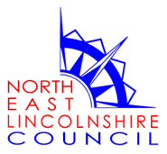 | 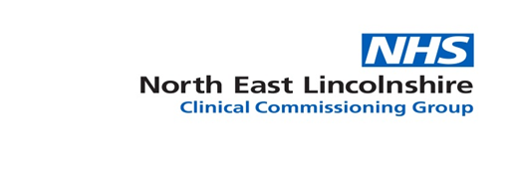

Modern Slavery & Human Trafficking Statement

Joint statement by NHS North East Lincolnshire Clinical Commissioning Group &
North East Lincolnshire Council.

The Modern Slavery Act 2015 has introduced changes in UK law focused on increasing transparency in employment practices, to ensure these are free from modern slavery (that is, slavery, servitude, forced and compulsory labour and human trafficking).
As local leaders in commissioning and provision of health and care services for the population of North East Lincolnshire, and as employers ourselves, NHS North East Lincolnshire Clinical Commissioning Group (CCG), and North East Lincolnshire Council (NELC) provide the following statement to offer assurance of their commitment and efforts to prevent slavery and human trafficking practices in our business activity and our employment practices.
Our Organisations
As authorised statutory bodies, both the CCG and NELC are commissioners (CCG and NELC) and providers (NELC) for health and care services including mental health services, acute, community, primary and social care services in the North East Lincolnshire area, covering a population in excess of 170,000.
Please see the CCG and NELC vision and aims via the following link:
http://www.northeastlincolnshireCCG and NELC.nhs.uk/our-aims/
https://www.nelincs.gov.uk/council-information-partnerships/partnerships/commissioning-plan-outcomes-framework/
Our commitment to prevent slavery and human trafficking
The CCG and NELC Union Board, Senior Leadership Team, and all employees are committed to ensuring that there is no modern slavery or human trafficking in any part of our business activity, and in so far as is possible, through holding our providers or suppliers to account to do likewise.
Our approach
Our overall approach will be governed by compliance with legislative and regulatory requirements and the maintenance and development of good practice in the fields of contracting and employment.

Our policies and arrangements
Our recruitment processes are highly mature – requiring operational practice that adheres to safe recruitment principles. This includes strict requirements in respect of identity checks, work permits and criminal records/ DBS checks. This safe recruitment principle is supported by Recruitment and Selection policy.
Our policies such as Bullying and Harassment at Work policy, Equality and Diversity policy and Whistleblowing policy provide an additional platform for our employees to raise concerns about poor working practices.
Our Multi-agency Safeguarding policies and procedures also provide guidance in relation to managing potential cases of slavery and human trafficking for employees.
The CCG procurement approach follows the Crown Commercial Service standard. NELC use a standard selection questionnaire. When procuring non-clinical goods and services, the CCG applies NHS Terms and Conditions and utilises the NHS Standard Contract for all clinical procurement. NELC have standard terms and conditions for goods, services and works that providers are expected to self-assess against to ensure they are compliant. Both require suppliers to comply with relevant legislation.
During 2020-21, we will continue to raise awareness of the Modern Slavery Act 2015 internally and as part of all procurement processes we will request all providers to set out evidence of their plans and arrangements to prevent slavery in their activities and supply chain.
This statement is made pursuant to section 54 (1) of the Modern Slavery Act 2015 and constitutes our slavery and human trafficking statement for the financial year ending 31 March 2021.

Signed: Jan Haxby
Role: Director of Quality and Nursing
Date: 4 March 2020

Signed: Bev Compton
Role: Director of Adult Social Services
Date: 4 March 2020

