**PRIVACY NOTICE FOR CHILDREN AND YOUNG ADULTS**

Introduction

This notice is to let you know why and how we collect your personal information and how this information is used. Sometimes you are allowed to decide how your information is used but there are also times where your information will have to be used to give you care you need. North East Lincolnshire Clinical Commissioning Group (CCG) is responsible for make sure health and care services are provided to you when you need them. To do this the CCG will need to use your personal information. The CCG must keep your information safe at all times.

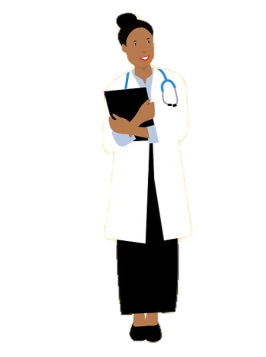



**What is “personal information”?**

Personal information lets the CCG identify you and includes such things as:

* Your name
* Your address and post code
* Your date of birth
* Any identifying numbers such as a hospital number given to you to use instead of your name

**How long do we keep your information?**

We will only keep your information for as long as the law allows us to. If we no longer need your information, it will be destroyed.

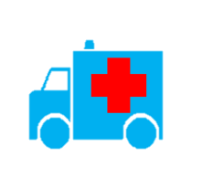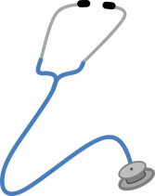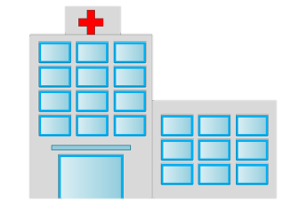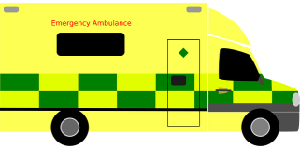

**How and why does the CCG collect and use personal information?**

Where the CCG collects and uses information about you this is to provide you with care to make sure you are given the help you need to stay safe and healthy. We can collect this information from you, your family and other people involved in giving you this help.

Here are some examples of why we collect your information:

* To help us plan health services you might need
* To keep you and others safe
* To follow the law

Sometimes we have to use your information, other times we will ask you for your permission. Where we ask for your permission this is called consent. If you are asked for your consent you can make choices about how your information is used, if you do not want to give consent you do not have to. If you are under 13 you may not be able to give consent on your own and we will ask your parent or guardian.

We may need to share your information with other organisations that care for you this may include schools, hospitals, local councils, and sometimes the police to help keep you safe.

**What decisions can you make about your information?** 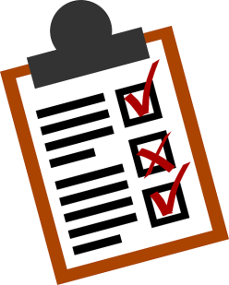

You can:

* ask for your information to be corrected if it has been recorded wrongly
* ask what information we have about you. We can give you a copy of your information and tell you why we have it, where it came from and who we have given it to
* you can ask for copies of some types of your information in a way that can be read by a computer
* you can ask to opt out of your patient records being used for research and planning; and

If you have any worries about the way the CCG is collecting or using your personal information, you can contact us at North East Lincolnshire CCG, Municipal Offices, Town Hall Square, Grimsby, DN31 1HU. Email: nelccg.askus@nhs.net OR you can talk to the Information Commissioner’s Office (ICO). You can telephone the ICO on 0303 123 1113. Or you can contact the ICO by email using the link below:

<https://ico.org.uk/global/contact-us/email/>